PROGRESS STATEMENT SUMMARY
California Institute of Technology
Fall 2008
Part I
Cyclic Charm Bracelet Summary

Using a cyclic polyammonium template, a polycatenane was synthesized via ring-closing metathesis of a bis-olefin containing polyether in the presence of the Grubbs 2nd generation catalyst. The cyclic template was prepared in a two-component click cyclization reaction. The nature of the interaction between the macrocyclic polyether and the cyclic polyammonium ion was investigated by two-dimensional diffusion ordered NMR spectroscopy.

Daisy-Chain Dimer Summary

We report the synthesis and development of three distinct [c2]Daisy-Chain Dimers (DCD) and efforts toward the incorporation of these DCD into materials. “Standard binding motif” (SBM) dimers are modeled from the original DCD structures reported by our group wherein the ammonium binding site and crown-type moiety are juxtaposed within the structure of the macromer. In contrast to the original DCD, however, these new SBM DCD have a long alkyl backbone separating the binding site from the cap, a feature that should allow for increased flexibility and movement of the crown ether upon removal of the binding interactions (i.e., deprotonation of the ammonium). There are two “Generations” of SBM DCD described. The Generation I SBM DCD had an unstable ester linkage coupling the cap to the backbone, and rapidly cleaved in the presence of acid or base to generate a pseudorotaxane species. This instability is addressed in the Generation II SBM DCD by utilizing a phenol linkage in place of the ester.
Though these SBM DCD are intriguing species, we believed it prudent to explore an interlocked architecture whose movement would more closely mimic a biological muscle (i.e., the bound state of the dimer represents its shortest-length conformation). To this end, we report the synthesis of a “Reverse Binding Motif” (RBM) DCD, the product of the dimerization of a macromer with a molecular topology wherein the binding and recognition moieties are separated in the backbone. Furthermore, post-dimerization purification and functionalization techniques have been elucidated that facilitate the inclusion of the RBM DCD within a polymeric chain or gel network. Several attempts to study these dimer-gels were made, but none were successful due to the fragile and brittle properties of the gel. Consequently, we have turned our attention to the development of several new trialkyne crosslinking agents in an effort to produce ‘softer’ gels more amenable to study.

MURI Progress Report
Erin Guidry, Paul Clark, Wing Yan Chan, and Robert H. Grubbs
7 / 25 / 2008

INTERLOCKED COMPOUNDS

Magic Charm Bracelet Synthesis
Erin Guidry, Paul Clark, Wing Yan Chan, and Robert H. Grubbs

Polycatenane Formation via Clipping.
Inspiration for the formation of cyclic polycatenanes can be found in the vast number of syntheses of catenanes and rotaxanes that have appeared in the chemical literature. Most of the strategies employ kinetically-controlled covalent bond formation as the final interlocking step.¹ This strategy does not always result in high yields of mechanically interlocked compounds because of the irreversible formation of unwanted non-interlocked by-products. An alternative strategy, however, exploits dynamic covalent chemistry,² an approach that utilizes reversible reactions in which the product distribution depends on thermodynamic rather than kinetic control. This way, the yield of a mechanically interlocked compound reflects its stability relative to those of any other non-interlocked by-products, with proof-reading and error-checking operating up until a final equilibrium state is reached. Examples of equilibrium reactions employed as the final bond-forming step in the synthesis of catenanes and rotaxanes include the reversible formation of imines,³ disulfides⁴ and cyclic acetals,⁵ as well as olefin metathesis mediated by functional-group tolerant ruthenium alkylidene catalysts.⁶ This protocol has been applied successfully in the syntheses of both [2]catenanes,⁷ [2]rotaxanes,⁸ rotaxane bundles⁹ and [c2]daisy chain compounds.¹⁰
Previously, we have demonstrated that the ring-closing of certain olefin-containing polyether substrates around appropriately-substituted secondary dialkylammonium ions results¹¹ (eq 1) in the reversible formation of [2]rotaxanes,^{8a} [2]catenanes,^{7a} rotaxane bundles⁹ and [c2]daisy-chain compounds.¹⁰ Thus, for example, by employing the ruthenium catalyst (H₂IMes)(PCy₃)(Cl₂)Ru=CHPh (5),¹² the macrocyclic polyether 4 containing two olefinic double bonds can be induced to undergo ring-closing metathesis in the presence of the macrocyclic compound 3-H·PF₆, wherein the ammonium center acts as the template for the formation of the [2]catenane 6-H·PF₆. Utilizing this strategy, we decided to explore the ring-closing metathesis (RCM) of polyether substrates around cyclic, polymeric secondary dialkylammonium ions as a method to synthesize the elusive cyclic polycatenane.
To synthesize the desired cyclic polyammonium ion, we chose a polymer cyclization method based on the copper-catalyzed Huisgen dipolar cycloaddition (“click” reaction) of terminal alkynes and azides to form 1,4-disubstituted 1,2,3-triazoles.¹³ This “click” reaction has been used extensively in polymer and materials chemistry due to its high efficiency and operational simplicity, and has more recently been used to synthesize cyclic polystyrene.¹⁴ A challenge in preparing macrocyclic polymers using “click” cyclization is that few polymers can be efficiently synthesized with appropriate end groups. Ring-opening metathesis polymerization (ROMP) in the presence of chain transfer agents (CTA) allows for the preparation of end functionalized (telechelic) polymers with good molecular weight control and relatively narrow polydispersities.¹⁵
ROMP monomer 13, was identified as a synthetic target due to the sufficient ring-strain of 9-membered rings¹⁶ and the presence of a protected nitrogen, which, upon further manipulation, could be transformed into a dialkylammonium ion. As outlined in Scheme 1, cyclooctadiene (COD) was monoepoxidated (mCPBA/CHCl₃) to form 7. This epoxide was subsequently ring-opened (LiAlH₄/THF) to yield alcohol 8. Standard Swern¹⁷ conditions (DMSO/oxalyl chloride/CH₂Cl₂/Et₃N) oxidized alcohol 8 to ketone 9. Ketone 9 was then transformed to oxime 10 using NH₂OH.HCl, and then tosyl-oxime 11 (TsCl/pyridine). A base-catalyzed Beckman rearrangement¹⁸ (K₂CO₃/THF) provided lactam 12, as a mixture of regioisomers (no attempt was made to separate these regioisomers), which was reduced to the corresponding amine (LiAlH₄/THF) and protected with a Boc group (Boc₂O/CH₂Cl₂) to yield ROMP monomer 13.

Scheme 1: Synthesis of ROMP monomer 13.

Although CTAs have been utilized in ROMP, no CTAs containing azide functionalities have been previously reported. To test the use of an azide-functionalized CTA in ROMP, COD was polymerized in the presence of azide-terminated CTA 14 using metathesis catalyst 15 under standard ROMP conditions (eq 2). Initially green, the reaction color became black after only a few minutes, likely indicating catalyst decomposition. Additionally, the molecular weight of resulting polymer, 16, was much higher than the theoretical molecular weight (based on the ratio of [monomer]:[CTA]) and contained no CTA incorporation. Based on these observations, it is hypothesized that the azide functionalities caused catalyst decomposition. Due to its large ring-strain energy, the COD monomer polymerized before complete catalyst decomposition; however the chain transfer process, which is much slower, did not take place.
However, telechelic polymer 19, containing azide end groups, was prepared from the corresponding dibromide telechelic polymer 18. ROMP of monomer 13 in the presence of CTA 17 and metathesis catalyst 15 yielded polymer 18. End-group modification of polymer 18 (NaN₃/DMF) afforded the diazide-terminated polymer 19 (Scheme 2).

Scheme 2: Synthesis of azide terminated telechelic polymer 19 via ROMP of monomer 13.

Cyclization of azide-terminated polymer 19 with 1,6-heptadiyne and CuBr was performed using a syringe pump to simulate ultrahigh dilution conditions. After the click cyclization reaction was complete, alkyne- and azide- terminated scavenging resins were added to remove linear polymer (eq 3).
°C
Confirmation of Cyclic Structure of Polymer 20.
¹H NMR spectroscopy was used to verify the chemical transformation of the end groups (Figure 4). Resonance observed at 3.25 ppm, corresponding to the azide-adjacent protons (a), is clearly observed in the starting polymer 19. After the cyclization and bead purification, resonances at 3.25 ppm disappear and new resonances at 4.12 ppm corresponding to the triazole-adjacent protons (a’) are observed. Further evidence for the formation of triazole was observed in the FTIR spectra by monitoring the disappearance of azide (2090 cm⁻¹) peak (Figure 5). Additionally, MALLS-GPC (multi-angle laser light scattering-gel permeation chromatography) data indicates that no higher molecular weight condensation products, such as dimers or trimers, have formed. As the GPC data exclude the possibility of higher oligomer condensation, nearly quantitative formation of the triazole confirms conversion to the cyclic polymer.
Additional end-group information was obtained using MALDI-MS (Figure 6). While MALDI-MS cannot be used to confirm the molecular weight of the polymer samples, several repeat units were visible and it is possible to obtain the molecular weight of the end group of 20. The end-group mass (286) may be determined by subtracting the mass of the monomer (225) and the mass of the MALDI-MS matrix (186) from the mass of the lowest visible repeat unit (700). An end-group mass of 286 could correspond to either a cyclized product, or a monoreacted uncyclized product (Figure 6). Due to the absence of appropriate ¹H NMR spectroscopy signals and FTIR spectroscopy peaks, it can be concluded that the observed MS peaks correspond to the cyclic polymer 20.

Figure 4: Partial ¹H NMR spectra of linear polymer 19 and cyclic polymer 20. Peak labels are defined in eq. 3.

Figure 5: FTIR spectra of linear azide terminated polymer 19 and cyclic polymer 20 after click cyclization.

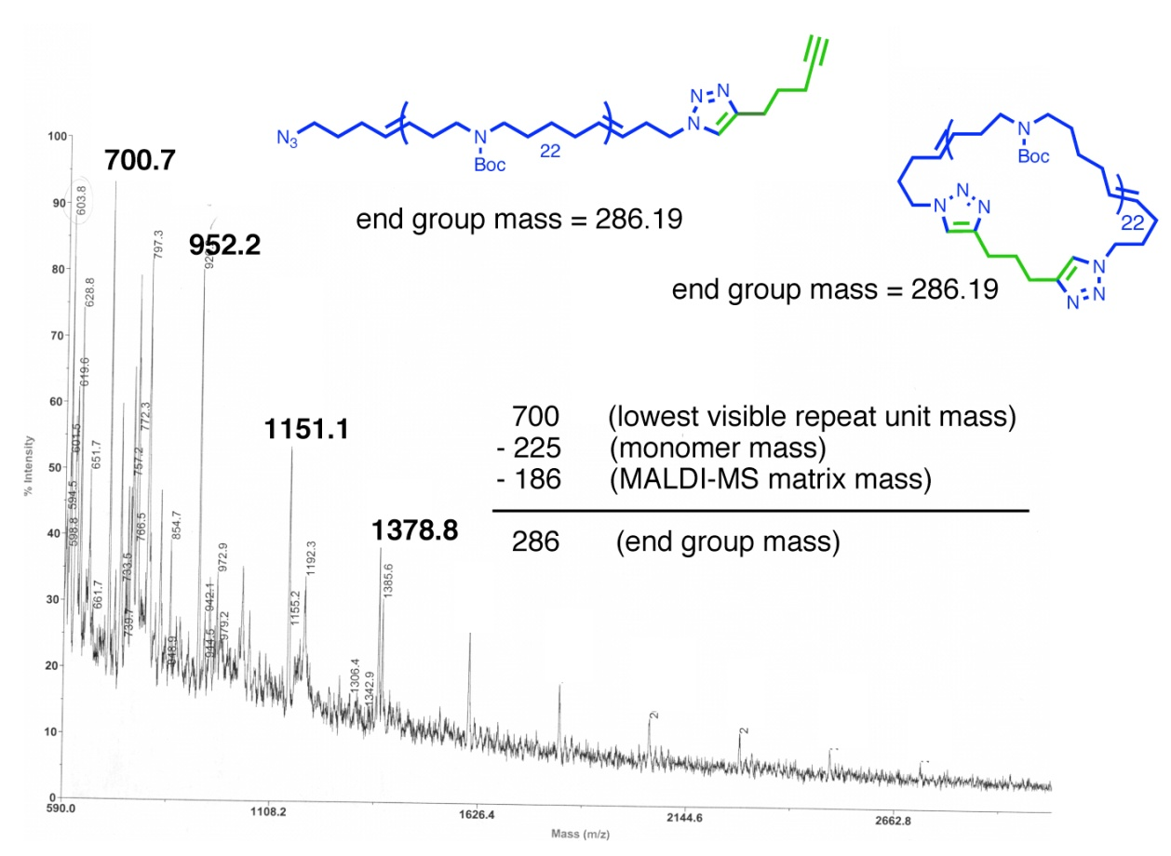
Although the experiments described above have shown the absence of any azide end group in the polymer sample, no evidence for the presence or absence of alkyne end groups in the polymer sample has been obtained. Polymer 20 and ¹H NMR spectroscopy labeling agent 21 were reacted under standard click polymer cyclization conditions (CuBr/bipyridine/DMF/120 °C), followed by the addition of alkyne-terminated resin to remove any excess labeling reagent (Figure 7). The ¹H NMR spectrum of cyclic polymer sample 20 after this labeling experiment showed no signals corresponding to labeling agent 21 (Figure 7). A similar experiment using fluorine-containing labeling agent 22 was performed, and no signal corresponding to 22, was observed in the ¹⁹F NMR spectrum. These experiments indicate that there are no alkyne end groups present in cyclic polymer 20. The end group-analysis experiments indicate that there are neither azide (based on ¹H NMR, FTIR, and MALDI-MS data) nor alkyne (MALDI-MS and labeling experiments) end groups present in polymer sample 20, supporting the cyclic structure of the polymer.
Figure 6: MALDI-MS spectrum of ‘cyclic’ polymer 20 after click cyclization.
Figure 7: End-group analysis of cyclic polymer sample 20 using labeling experiments.
°C
°C
Perhaps the most informative experiment regarding the structure of polymer 20 exploits the molecular recognition between crown ether macrocycles and appropriately substituted ammonium ions. This technique does not depend on end group identification, but, instead, relies on the most fundamental difference between linear and cyclic polymers—namely, the presence or absence of chain ends. Linear polyammonium ion 23 will thread [24]crown-8 (24) nearly quantitatively in CD₃CN after an equilibration period of 24 hours, as confirmed by ¹H NMR spectroscopy. After only a few minutes, resonances are observed in the ¹H NMR spectrum at δ ~ 3.2 ppm, corresponding to the NH₂⁺-adjacent methylene protons (a') in an environment where they are encircled by a crown ether-like macrocycle. Furthermore, resonances at δ ~ 3.0 ppm corresponding to ‘free’ ammonium sites on the polymer chain (a) are observed to diminish in intensity. If [24]crown-8 (24) is added to cyclic polyammonium ion 26, no change in chemical shift is observed in the region between δ ~ 3.0–3.2 ppm, thus unambiguously confirming the ‘endless’ structure of cyclic sample 20 (Figure 8).
Figure 8: Linear polymer template 23 will thread [24]crown-8 (24), forming psuedorotaxane 25. ‘Endless’ cyclic polymer template 26 cannot thread [24]crown-8 (24) due to its cyclic structure.

Synthesis of Cyclic Polycatenane using RCM.
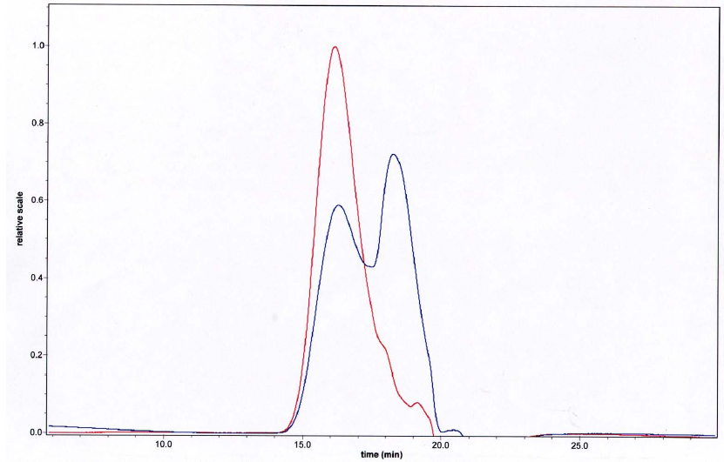
Recently, we have prepared an analog of cyclic polymer 20 where 1,4-diethynylbenzene was used in the click cyclization (20a). As a solid, 1,4-diethynylbenzene was easier to handle compared to 1,6-heptadiyne. Using the previously described cyclization protocol, the click reaction gave a mixture of linear and cyclic polymers (Figure 9).
Hydrogenation of 20a using Wilkinson’s catalyst proceeded smoothly to give 27a. Deprotection (TFA/CH₂Cl₂), followed by counterion exchange (NH₄PF₆/MeOH), yielded cyclic polyammonium ion 28a (Scheme 3).
Figure 9: GPC traces before (red) and after (blue) click cyclization to give cyclic polymer 20a.
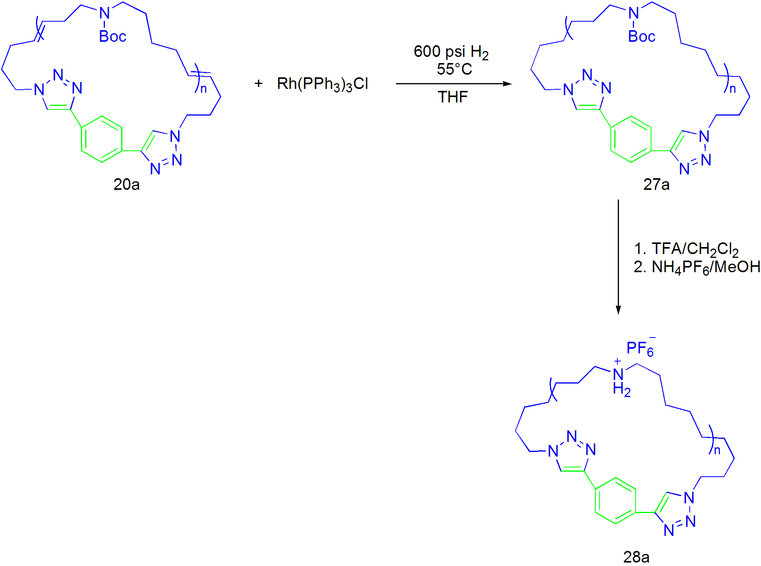
Ring-closing of the terminal olefin functions in the acyclic polyether 4 in the presence of the cyclic polymer template 28 and metathesis catalyst 5 afforded greater than 95% conversion to the ring-closed polyether. However, no change in chemical shift was observed in the characteristic region (δ ~ 3.0-3.2 ppm) corresponding to the ammonium-adjacent methylene protons (a') in an environment where they are encircled by a crown ether-like macrocycle (Figure 10). The polymer template 28 and crown ether 30 have very different solubilities, a property which can be exploited to purify the polymer sample. Repeated precipitation of the reaction mixture (CH₂Cl₂/Et₂O) did not, however, remove the majority of crown ether 30, as is evident in the ¹H NMR spectrum. Additional purification using size exclusion chromatography (SEC), also failed to remove remaining crown ether 30. This led us to speculate that crown ether 30 might have an intimate association with the polymer template 28 to form catenation product 29. MALDI-MS is a useful technique to probe this issue, however using a variety of matrices, the sample proved unsuitable for analysis.
Figure 10: Two possible products of the ring-closing metathesis of bis-olefin containing polyether 4 in the presence of cyclic polymer template are presented: (i) the interlocked product, [2]catenane 29 or (ii) a mixture of non-interlocked products crown 30 and cyclic polymer template 28.
Scheme 3: Synthesis of cyclic polymer template 28a.
°C
To investigate this hypothesis further, threading experiments between the linear polymer template 23 and crown 30 were performed (Figure 11). Interestingly, upon mixing linear polymer template 23 with the crown ether-like macrocycle 30 in CD₃NO₂, no change in chemical shift was observed in the characteristic region (δ ~ 3.2 ppm), corresponding to the ammonium-adjacent methylene protons (a') encircled by a crown ether-like macrocycle. Two possible explanations for these observations are (i) that crown ether-like macrocycle 30 is threading around polymer template 23 but not causing a detectable change in chemical shift, or (ii) that is there no threading between crown 30 and polymer template 23.
Figure 11: Two possible product mixtures, polypseudorotaxane 31 or a mixture of 23 and 30 may result from the mixing of linear polymer template 23 and crown-like macrocycle 30.
23
Two-dimensional diffusion-ordered NMR spectroscopy (2D-DOSY)¹⁸ has been used previously to examine rotaxanated polymers and other host-guest assemblies in which a change in chemical shift upon threading or assembly is not detectable.²⁰ 2D-DOSY can be used to correlate diffusion coefficients (D) with molecular structure via chemical shifts. Self-diffusion depends on molecular size, with smaller molecules diffusing more quickly than larger molecules. In the case of polyrotaxanes, the threading macrocycles are typically much smaller than the polymeric backbone they encircle, and, therefore, have much faster diffusion raters. However, when the macrocycle is threaded onto the polymeric backbone, the macrocycle self-diffusion is controlled by the polymer self-diffusion.
We first validated the 2D-DOSY method by examining the threading behavior of linear polymer template 23 and [24]crown-8 (24). There is an observable change in chemical shift in the ¹H NMR spectrum from δ ~ 3.0 to 3.2 ppm corresponding to the ammonium-adjacent methylene protons (a') encircled by a crown ether-like macrocycle (Figure 12). Indeed, a distinct change in the self-diffusion coefficient of [24]crown-8 (24) is evident in the DOSY spectrum and is similar to the self-diffusion coefficient observed in the polymer sample. A diffusion coefficient (logD) –9.1 m²s⁻¹ (c) corresponding to ‘free’ [24]crown-8 (24) is evident in the 2D-DOSY spectrum along with a diffusion coefficient of (logD) –9.9 m²s⁻¹ (c’) corresponding to ‘threaded’ [24]crown-8 (24). The threaded crown (c’) has a very similar self-diffusion coefficient (p) to that of the polymer template 23, indicating that the diffusion of the threaded crown is governed by that of the polymer template.
Figure 12: 2D-DOSY spectrum of polypseudorotaxane 25 formed from mixing [24]crown-8 (24) and polymer template 23. A diffusion coefficient (logD) of –9.1 m²s⁻¹ corresponding to unthreaded crown (c) is evident along with a diffusion coefficient of –9.9 m²s⁻¹ corresponding to threaded crown (c’). Both polymer template 23 and polypseudorotaxane 25 have the same self-diffusion coefficient and are labeled (p).

Next, the threading behavior of linear polymer template 23 and crown-like macrocycle 30 was examined (Figure 13). In this sample, no observable change in chemical shift of the ammonium-adjacent methylene protons (a') encircled by a crown ether-like macrocycle was observed in the ¹H NMR spectrum (δ ~ 3.0 ppm) upon addition of 30, thus it was unclear if any polymer threading was occurring. While the spectrum is more complex due to the lower symmetry of crown-like macrocycle 30, a distinct change in the self-diffusion is evident in the 2D-DOSY spectrum and is similar to the self-diffusion coefficient observed for polymer template 23. A diffusion coefficient of (logD) –9.1 to –9.5 m²s⁻¹ (c) corresponding to ‘free’ crown-like macrocycle 30 is evident in the 2D-DOSY spectrum, along with diffusion coefficients of (log D) –9.6 to –10.0 m²s⁻¹ (c’) corresponding to ‘threaded’ crown-like macrocycle 30. The threaded crown (c’) has a very similar self-diffusion coefficient (p) to that of polymer template 23 indicating that the diffusion coefficient of the threaded crown is governed by that of the polymer template.
Figure 13: 2D-DOSY spectrum of polypseudorotaxane 31 formed from mixing crown-like macrocycle 30 and polymer template 23. The diffusion coefficient at –9.2 m²s⁻¹ corresponding to unthreaded crown (c) is evident along with diffusion coefficients of –9.5 to –10.0 m²s⁻¹ corresponding to threaded crown (c’). Both polymer template 23 and polypseudorotaxane 31 have the same self-diffusion coefficients and are labeled (p).
Encouraged by the successful application of 2D-DOSY to the threaded system, we attempted to use this technique to investigate the reaction mixture resulting from RCM of 4, catalyzed by 5, in the presence of cyclic polymer template 28. Possible outcomes included formation of cyclic polycatenane 29 or a mixture of non-interlocked crown 30 and polymer 28. Unfortunately 2D-DOSY experiments did not yield conclusive results (Figure 14). A diffusion coefficient of (logD) –8.6 m²s⁻¹ (c) corresponding to a crown-like macrocycle was evident in the 2D-DOSY spectrum along with diffusion coefficients of (logD) –8.6 m²s⁻¹ corresponding to a polyammonium ion. The exact structure, however, could not be determined due to the unusually rapid diffusion exhibited by the polyammonium ion. The diffusion coefficient of the cyclic polyammonium ion in this spectra was much larger (logD = –8.6 m²s⁻¹) than for linear polyammonium ions 23 or 31 (logD = –10.0 m²s⁻¹). This result was unexpected, and made precise identification of the polymeric structure using 2D-DOSY impossible.
Figure 14: 2D-DOSY spectrum of the reaction mixture resulting from the ring-closing metathesis of the acyclic polyether 4 in the presence of the cyclic polymer template 28 using metathesis catalyst 5. Possible outcomes include formation of cyclic polycatenane 29 or a mixture of crown 30 and polymer 28. The diffusion coefficient at –8.6 m²s⁻¹ corresponding to crown (c) is evident along with diffusion coefficients of –8.6 m²s⁻¹ corresponding polymer, which are labeled (p).
Attempted purification of cyclic polymer 28a using [24]crown-8.
As shown in Figure 8, [24]crown-8 will thread a linear polyammonium template but not a cyclic polyammonium template. Since CH₂Cl₂ is a good solvent only for threaded linear polymer 25, this difference in solubility may be exploited to separate the two species.
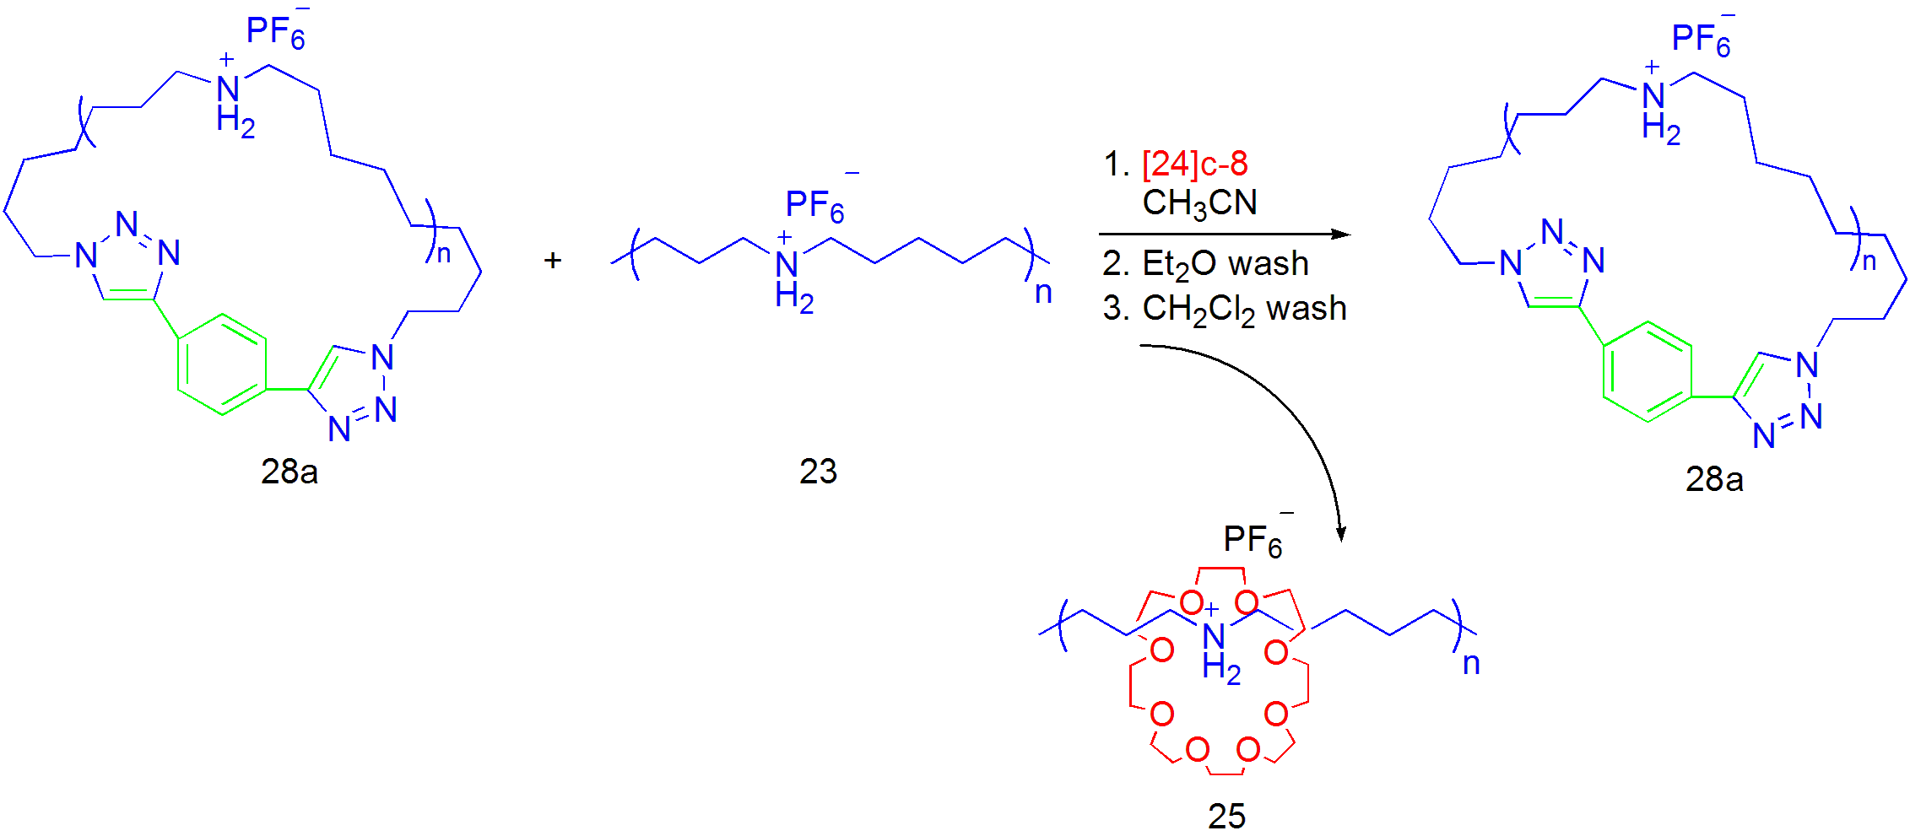
We have recently tried to remove the linear impurities in cyclic polymer 28a using this protocol (Figure 15). Treatment of 28a with an equimolar amount of [24]crown-8 resulted in threading after 24 h. After washing the reaction mixture with CH₂Cl₂, most of the threaded linear polymer 25 was removed. However, trace amounts of [24]crown-8 and 25 remained, even after repeated washing with CH₂Cl₂.
Figure 15: Purification of cyclic polymer 28a using [24]crown-8.

Future Directions.
Purification of cyclic polymer 28a remains a challenging task. Since we have had some success using [24]crown-8 to remove linear polymer contaminants, it is possible that the same strategy can be used after the clipping reaction shown in Figure 10. Washing with CH₂Cl₂ should remove most of the threaded linear polymer impurities, leaving behind pure charm bracelet 29.
The clipping reaction shown in Figure 9 should be further explored to improve cyclization efficiency. So far, only catalyst 5 was used in this reaction. Catalyst 15 is more active and more functional group tolerant, which may show improved reactivity in the clipping reaction. The effects of solvent should also be investigated. Metathesis-compatible solvents such as acetone and dimethoxyethane may be a better solvent for cyclic polymer 28. If the polymer exists in a relaxed conformation in solution, this may result in enhanced interactions between bis-olefin containing polyether 4 and the polymer template and increased clipping efficiency. Once the clipping efficiency is improved, the DOSY experiments should give a more definitive proof for the formation of a cyclic polycatenane.

References.
(1) (a) Dietrich-Buchecker, C. O.; Sauvage, J.-P.; Kern, J. M. J. Am. Chem. Soc. 1984, 106, 3043–3045. (b) Hunter, C. A. J. Am. Chem. Soc. 1992, 114, 5303–5311. (c) Vögtle, F.; Jager, R.; Handel, M.; Ottens-Hildebrandt, S. Pure Appl. Chem. 1996, 68, 225–232. (d) Gong, C. G.; Gibson, H. W. Angew. Chem., Int. Ed. 1998, 37, 310–314. (e) Kolchinski, A. G.; Busch, D. H.; Alcock, N. W. J. Chem. Soc., Chem. Commun. 1995, 1289–1291. (f) Hansen, J. G.; Feeder, N.; Hamilton, D. G.; Gunter, M. J.; Becher, J.; Sanders, J. K. M. Org. Lett. 2000, 2, 449–452. (g) Shukla, R.; Deetz, M. J.; Smith, B. D. Chem. Commun. 2000, 2397–2398. (h) Hubbard, A. L.; Davidson, G .J. E.; Patel, R. H.; Wisner, J. A.; Loeb, S. J. Chem. Commun. 2004, 2, 138–139. (i) Sasabe, H.; Kihara, N.; Furusho, Y.; Mizuno, K.; Ogawa, A.; Takata, T. Org. Lett. 2004, 6, 3957–3960. (j) Hernandez, J. V.; Kay, E. R.; Leigh, D. A. Science 2004, 306, 1532–1537.
(2) (a) Rowan, S. J.; Brady, P. A.; Sanders, J. K. M. Angew. Chem., Int. Ed. Engl. 1996, 35, 2143–2145. (b) Lehn, J.-M. Chem. Eur. J. 1999, 5, 2455–2463. (c) Lehn, J.-M.; Eliseev, A. V. Science 2001, 291, 2331–2332. (d) Otto, S.; Furlan, R. L. E.; Sanders, J. K. M. Science 2002, 297, 590–593. (e) Rowan, S. J.; Cantrill, S. J.; Cousins, G. R. L.; Sanders, J. K. M.; Stoddart, J. F. Angew. Chem., Int. Ed. 2002, 41, 898–952. (f) Corbett, P. T.; Otto, S.; Sanders, J. K. M. Org. Lett. 2004, 6, 1852–1827.
(3) (a) Cantrill, S. J.; Rowan, S. J.; Stoddart, J. F. Org. Lett. 1999, 1, 1363–1366. (b) Rowan, S. J.; Stoddart, J. F. Org. Lett. 1999, 1, 1913–1916. (c) Glink, P. T.; Oliva, A. I.; Stoddart, J. F.; White, A. J. P.; Williams, D. J. Angew. Chem., Int. Ed. 2001, 40, 1870–1875. (d) Horn, M.; Ihringer, J.; Glink, P. T.; Stoddart, J. F. Chem. Eur. J. 2003, 9, 4046–4054. (e) Chichak, K. S.; Cantill, S. J.; Pease, A. R.; Chiu, S.-H.; Cave, G. W. V.; Atwood, J. L.; Stoddart, J. F. Science 2004, 304, 1308–1312. (f) Hogg, L.; Leigh, D. A.; Lusby, P .J.; Morelli, A.; Parsons, S.; Wong, J. K. Y. Angew. Chem., Int. Ed. 2004, 43, 1218–1221. (g) Schalley, C. A. Angew. Chem., Int. Ed. 2004, 43, 4399–4401. (h) Cantrill, S. J.; Chichak, K. S.; Peters, A. J.; Stoddart, J. F. Acc. Chem. Res. 2005, 38, 1–9.
(4) (a) Kolchinski, A. G.; Alcock, N. W.; Roesner, R. A.; Busch, D. H. Chem. Commun. 1998, 1437–1438. (b) Furusho, Y.; Oku, T.; Hasegawa, T.; Tsuboi, A.; Kihara, N.; Takata, T. Chem. Eur. J. 2003, 9, 2895–2903.
(5) Fuchs, B.; Nelson, A.; Star, A.; Stoddart, J. F.; Vidal, S. B. Angew. Chem., Int. Ed. 2003, 42, 4220–4224.
(6) Trnka, T. M; Grubbs, R. H. Acc. Chem. Res. 2001, 34, 18–29.
(7) (a) Kidd, T. J.; Leigh, D. A.; Wilson, A. J. J. Am. Chem. Soc. 1999, 121, 1599–1600. (b) Weck, M.; Mohr, B.; Sauvage, J.-P. Grubbs, R. H. J. Org. Chem. 1999, 64, 5463–5471. (c) Arico, F.; Mobian, P.; Kern, J. M.; Sauvage, J.-P. Org. Lett. 2003, 5, 1887–1890. (d) Iwamoto, H.; Itoh, K.; Nagamiya, H.; Fukazawa, Y. Tetrahedron Lett. 2003, 44, 5773–5776. (e) Wang, L. Y.; Vysotsky, M. O.; Bogdan, A.; Bolte, M. Böhmer, V. Science 2004, 304, 1312–1314. (f) Guidry, E. N.; Cantrill, S. J.; Stoddart, J. F.; Grubbs, R. H. Org. Lett. 2005, 7, 2129–2132.
(8) (a) Wisner, J. A.; Beer, P. D.; Drew, M. G. B.; Sambrook, M. R. J. Am. Chem. Soc. 2002, 124, 12469–12476. (b) Hannam, J. S.; Kidd, T. J.; Leigh, D. A.; Wilson, A. J. Org. Lett. 2003, 5, 1907–1910, (c) Coumans, R. G. E.; Elemans, J. A. A. W.; Thordarson, P.; Nolte, R. J. M.; Rowan, A. E. Angew. Chem., Int. Ed. 2003, 42, 650–654. (d) Kilbinger, A. F. M.; Cantrill, S. J.; Waltman, A. W.; Day, M. W.; Grubbs, R. H. Angew. Chem., Int. Ed. 2003, 42, 3281–3285.
(9) Badjic, J. D.; Cantrill, S. J.; Grubbs, R. H.; Guidry, E. N.; Orenes, R.; Stoddart, J. F. Angew. Chem., Int. Ed. 2004, 43, 3273–3278.
(10) Guidry, E. N.; Li, J.; Stoddart, J. F.; Grubbs, R. H. J. Am. Chem. Soc. 2007, 129, 8944-8945.
(11) (a) Glink, P. T.; Schiavo, C.; Stoddart, J. F.; Williams, D. J. Chem. Commun. 1996, 1483–1490. (b) Cantrill, S. J.; Pease, A. R.; Stoddart, J. F. J. Chem. Soc., Dalton Trans. 2000, 3715–3734. (c) Clifford, T.; Abushamleh, A.; Busch, D. H. Proc. Natl. Acad. Sci. USA 2002, 99, 4830–4836.
(12) Scholl, M.; Ding, S.; Lee, C. W.; Grubbs, R. H. Org. Lett. 1999, 1, 953–956.
(13) Huisgen, R. In 1,3-Dipolar Cycloaddition Chemistry; Padwa, A., Ed.; Wiley: New York, 1984.
(14) Laurent, B. A.; Grayson, S. M. J. Am. Chem. Soc. 2006, 128, 4238-4239.
(15) (a) Maughon, B. R.; Morita, T.; Bielawski, C. W.; Grubbs, R. H. Macromolecules 2000, 33, 1929-1935. (b) Morita, T.; Maughon, B. R.; Bielawski, C. W.; Grubbs, R. H. Macromolecules 2000, 33, 6621-6623. (c) Bielawski, C. W.; Benitez, D.; Morita, T.; Grubbs, R. H. Macromolecules 2001, 24, 8610-8618.
(16) Hejl, A.; Scherman, O. A.; Grubbs, R. H. Macromolecules 2005, 38, 7214-7218.
(17) Omura, K.; Swern, D. Tetrahedron 1978, 34, 1651.
(18) Gawley, R. E. Org. React., 1988, 35, 1.
(19) (a) Morris, K. F.; Johnson Jr., C. S. J. Am. Chem. Soc. 1993, 115, 4291. (b) Schulze, D.; Stilbs, P. J. Magn. Reson. A 1993, 105, 54. (c) Persson, K.; Griffiths, P. C.; Stilbs, P. Polymer 1996, 37, 253. (d) Jerschow, A.; Muller, N. Macromolecules 1998, 31, 6573. (e) Hakansson, B.; Nyden, M.; Soderman, O. Collid Polym. Sci. 2000, 278, 399.
(20) Zhao, T.; Beckham, H. W.; Gibson, H. W. Macromolecules 2003, 36, 4833-4837.

